**EXPERIMENT 2**

**ER DIAGRAM FOR SAILOR BOAT DATABASE**

**Aim:** Draw an ER diagram of sailors database.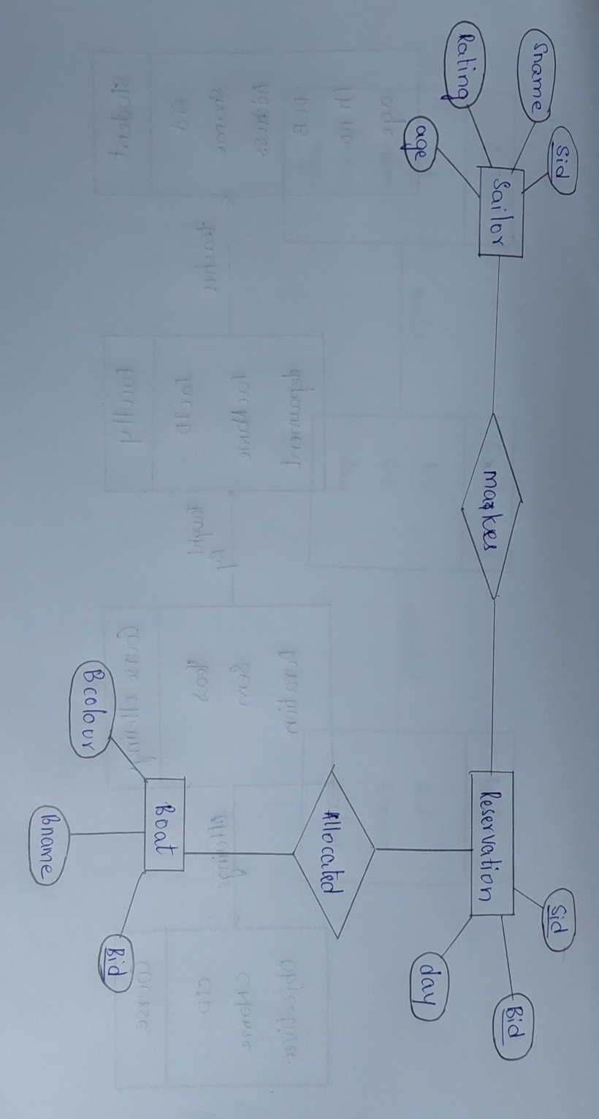

**Boats**

**makes**

**Reservation**

**Sailor**

**allocated**